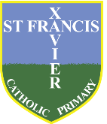
St Francis Xavier’s Recommended Reads for Year Three

At St Francis Xavier we want to encourage children to read a wide variety of high-quality books. We want children to develop a love of reading so we have devised a set of recommended books for each year group. This is a guide for children, parents and teachers to suggest books at an appropriate level in terms of interest, vocabulary, and complexity of plot. The following recommendations represent a range of genres which we hope will develop your child’s reading (and writing) skills. Not all the obvious books are here and the list is far from exhaustive! However, we hope amongst this selection there will be a book or an author that becomes a family favourite for your child. We have some of these books in school and you will be able to borrow them from the local library. Some of the books may be on a higher book band than your child is on – but don’t let that stop you - you can always share the book together. It is important that as well as reading books to adults, children have the opportunity to hear stories being read


