Autumn Term – Curriculum Newsletter – Year 3

Dear Parents/Carers,
This half term the children in Year 3 will be following a topic entitled…
The Stone Age

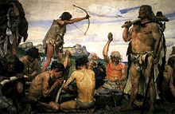
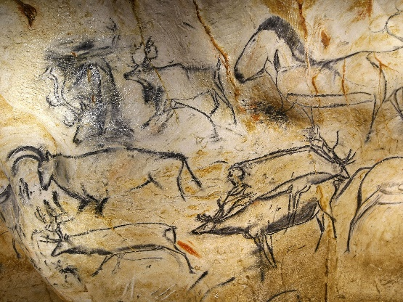

This newsletter will give you some ideas as to what your child(ren) will be learning about this half term.
Reading – Guided reading takes place every morning. Your child(ren) will learn how to use a dictionary to find words they don’t know the meaning of. This term, we have been reading ‘Stig of the Dump’ by Clive King. This is a fascinating fictional story about a boy who meets ‘Stig’. Stig lives in a dump. The story talks about the importance of friendship and about accepting difference. We use our inference and retrieval skills to answer challenging questions about the book.
Maths – This term the children will be consolidating and learning many skills relating to: Place Value, Addition and Subtraction.
English – The skills we will concentrate on are expanded noun phrases, conjunctions, direct speech and using ambitious vocabulary in our writing.
We will cover several genres this half term including instruction writing, character descriptions and writing a diary entry for our class book ‘Stig of the Dump.’
Science – This term the children will be learning how to make an experiment fair by discussing the different variables in an experiment. The first experiment we will look at is ‘How clean are our hands?’ This will show the importance of washing hands with soap and water.
In science, we will be focusing on the topic ‘Rocks’. We will compare and group different kinds of rocks based on their appearance. We will compare and group rocks based on their physical properties and predict which rocks would be suitable for different uses.
Art – Children will learn about Stone Age cave paintings and we will use techniques and different media to create our own.
PE – Your child will need to have their PE kit in school all week. Please ensure all t-shits, shorts and bags are clearly named as they often get mixed up during changing.
DT – In Design and Technology, we will be looking at Stone Age clay pots. We will research designs and use suitable techniques to create our own.
Music – In Music, we will look at the history of music and look at bone flutes from the Paleolithic era.
RE – Children will look at the topic ‘Homes’ where we will explore how all families are different and we will understand God’s dream for every family.
Homework – will continue to be handed out every Friday with the expectation of it being handed in by the following Friday. We would appreciate your support in encouraging your child to complete their homework on time to the best of their ability each week.
Home reading – Home reading continues to be an essential aspect of school and is part of the children’s homework. We have seen a huge impact on the reading skills of the children that have been regularly reading at home with grown up support. Please ensure that you read three times a week with your child and sign in the reading record so we can see when they have read and reward them in school.
Spellings and Keywords – Keywords are checked in class and always in a different order from the list. Spellings are tested weekly. It is also part of your child’s homework to practice their key words, to read and to spell every day with you.

Thank you for your support.
Miss Laite and Mrs Leneghan

