Go for a bike ride or a walk.  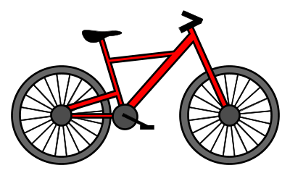 | Plant some flowers, do some gardening or water the plants you have.   | Make a nice fruit smoothie using your favourite fruits.   | Help a family member make dinner.   | Make a healthy snack, for example a fruit kebab.  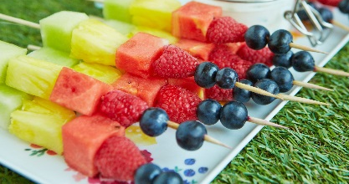
Exercise with Joe wicks or join in with supermovers.   | Read a book.   | Speak to a family member of friend on facetime or video call.  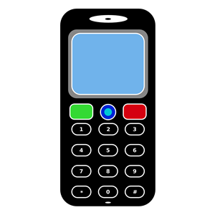 | Play your favourite music.   | Draw a poster to put in your window thanking somebody for what they do. Postman etc.  THANK YOU  
Have a mini disco with your favourite music.   | Draw a picture about how you are feeling.  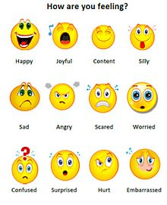 | Bake some buns or cookies.   | Do some yoga or guided meditation.  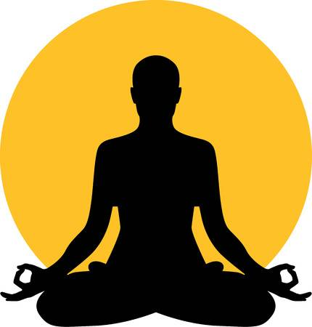 | Design a treasure hunt in your house/garden to do with a family member.  

