Breakfast Club Menu
At breakfast club we like to offer the children a wide variety of healthy breakfast choices to give them the best start to the school day. We are now offering the following menu on a daily basis:
Cereals
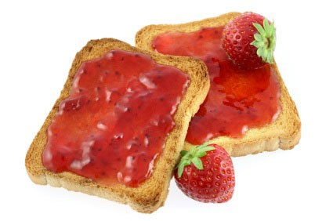
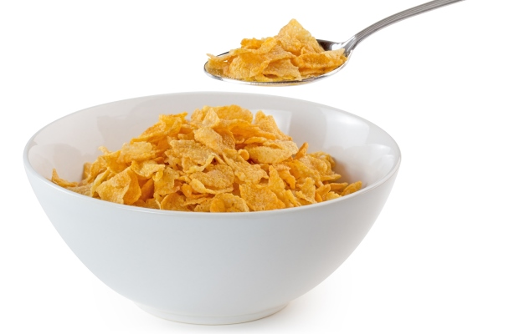
Cornflakes
Rice Krispies
Coco Pops
Shreddies
Frosted Flakes

Toast
Offered with a choice of toppings
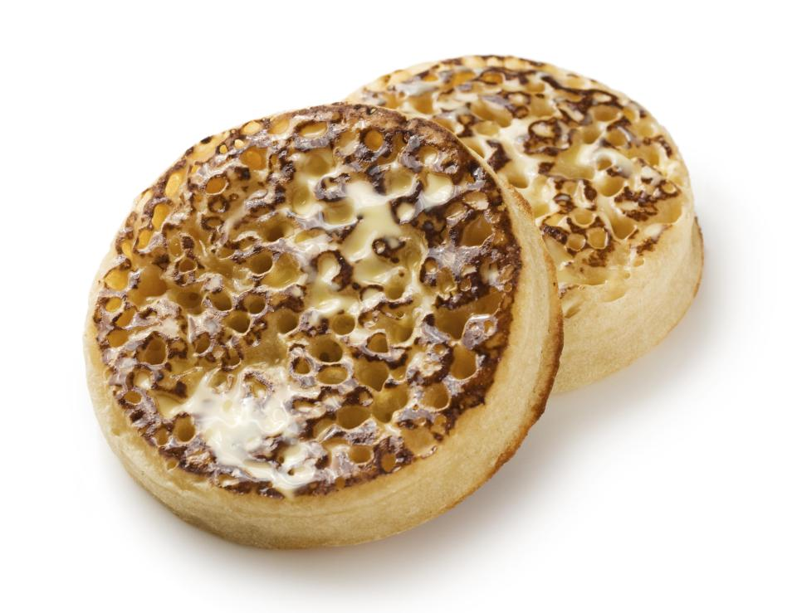
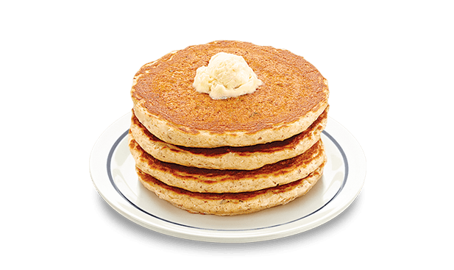

Crumpets
Offered with a choice of toppings

Pancakes

Fresh Fruit

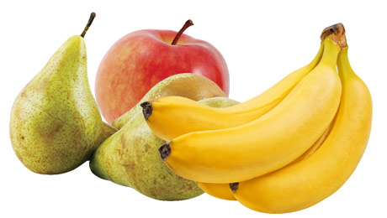
Pears
Bananas
Apples

Water and Orange and Blackcurrant cordial are also available.

*On some occasions the children may also be offered beans or spaghetti on toast.

