Guide to Accessing Google Classroom
- Download the Google Classroom App or search for Google Classroom using a web browser.
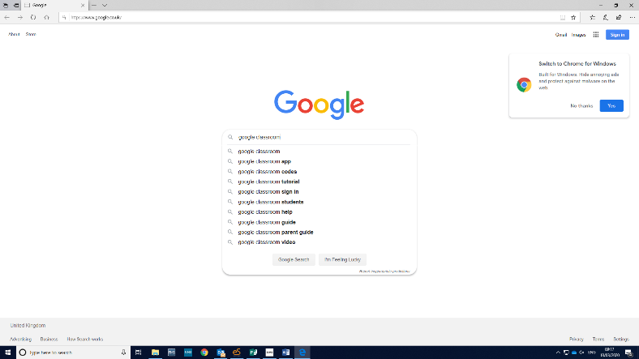

- Choose the Google Classroom option by clicking on it.

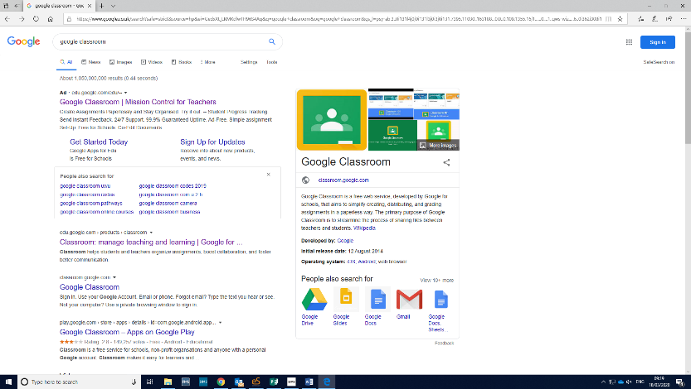

- Navigate to the top right hand corner where it says sign in and choose the google classroom option.
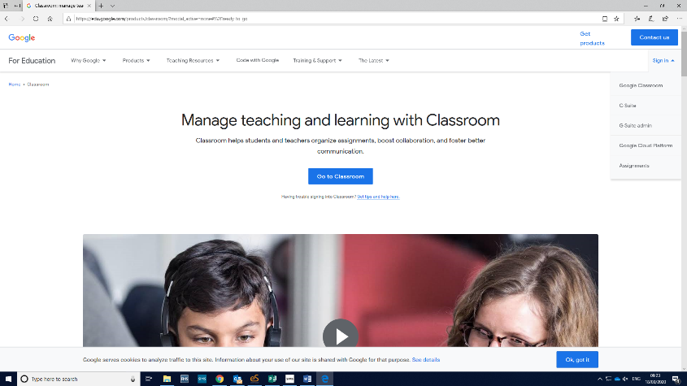

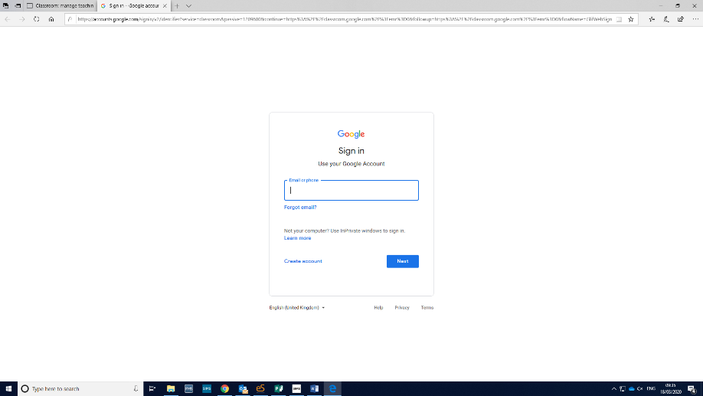
- Sign in using an existing google email address or create one for this purpose.

- Click the + sign at the top right hand corner & choose Join Class.
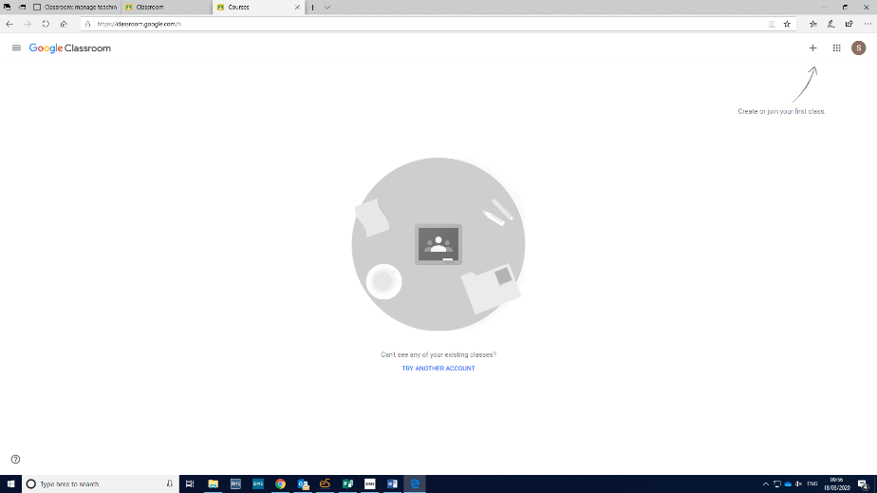

- Enter the class code (see code sent in email) and click join. The class page will appear and all available work will be shown. You will be able to ‘hand in’ completed work which the teacher will access.


